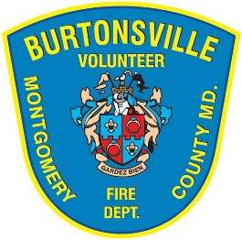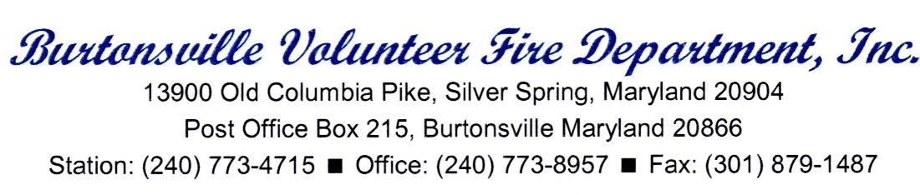
Position Description: Director of Operations
The “Director of Operations (DoO)” will administer, plan, and coordinate volunteer Officers and Firefighters in advancing the mission of the BVFD. The DoO will be directly responsible for supporting and developing the recruitment of personnel, overseeing their orientation, and the training and deployment of operational resources. The DoO will work with the volunteer Fire Chief and President on issues of policy and planning, and is accountable to the Board of Directors.
Duties and Responsibilities
- Scheduling of firefighters, to include:

  - Maintaining a published monthly calendar with member designated duty nights delineated.
  - Contacting all volunteer members via phone or others means of direct personal contact to verify duty night commitment for the month.
  - Publishing the weekly staffing schedule and update staffing board at least a week in advance, ensuring any duty night changes are properly recorded, and working to ensure an Operational Officer is present for each shift.
  - Ensuring adequate staffing in quarters for volunteer apparatus.
  - Identify and document volunteer members who are not meeting their duty night requirements and develop a plan with those members to increase their involvement.

- Officer meetings and development, to include:

  - Scheduling at least one Officer meeting each quarter, in consultation with the Fire Chief, to help address their needs, to develop their leadership skills, and clarify expectations of Officers.
  - Support Officers who manage training, EMS, and the BVFD live-in program by reinforcing and supporting initiatives and needs that are specific to these areas.
  - Member development, to include:
  - New members – oversee probationary fire members, ensuring new members are registered for needed classes, advancing them towards riding status, etc.
  - Establish and implement orientation guidelines for new recruits. This should include a system by which applicants are interviewed, vetted, and engaged in a timely manner.
  - Training advancement – actively advancing drivers by encouraging those eligible to work through drivers packet, providing training opportunities (either directly or through an approved Officer) to be checked off.
  - Training opportunities – coordinate and/or conduct weekly training drills to fulfill needs of firefighters in their maintenance and advancement of skills.
  - Dormant member outreach – making contact with trained (non IECS active) firefighters to stay abreast of their status and encourage them to return to operational participation.

- Day-to-day coordination, to include:

  - Plan, coordinate, and supervise the daily activities to ensure efficient operation of the BVFD as specified in the bylaws.
  - Ensure adequate records are kept of all required training and classes.
  - Maintain an effective working relationship with all BVFD and DFRS Officers and personnel.
  - Ensure inquires and complaints regarding fire department activities or responsibilities are handled promptly and professionally.
  - Act as a liaison between BVFD and representatives of local MCFRS in regards to staffing and training issues.
  - Manage any disciplinary situations which may arise in accordance with the bylaws and in close collaboration with the Fire Chief and President.
  - Provide monthly staffing reports to the BVFD leadership that document: staffing levels, response statistics, and volunteer member achievements and issues

- Long term staffing predictions, to include:

  - Working with the Board of Directors and Officers to determine needs and strategies in relation to forward planning (1 year, 3 years, 5 years) by analyzing participation and call data.

Qualifications and Skills

1. Possess excellent organizational skills and mastery of computer software and office equipment to support documentation, tracking, and written reports.

2. Familiarity with tracking tools and databases (possible examples include: SAMS, Crystal Reports, IECS, etc.)

3. Possess excellent communication and motivational skills, exhibiting the ability to lead/facilitate group discussions and to develop consensus positions; possess outstanding traits of dependability, teamwork and integrity.

4. Experience in fostering a positive environment and good working relationships within a combination volunteer and career organization.

5. Effectively able to mitigate, manage, and resolve complaints and disciplinary issues (when applicable) and report in a timely manner to the Fire Chief.

Education and Certifications
1. Associates degree in fire science, public management, political science, business administration, economics or a related field. Other combinations of experience and education with meet the minimum requirements may be substituted.
2. Eligibility to be appointed as a Certified Chief Officer to the Montgomery County Integrated Emergency Command Structure is beneficial, but not required.

3. Lieutenant or above, with a minimum of 10 years fire service and having held basic EMT certification within last 5 years.

4. Ability to pass an initial physical examination, and maintain throughout employment, a medical rating of “fit for duty – firefighter/rescuer” as evaluated by the Montgomery County Fire/Rescue Occupational Medical Services (FROMS.) This is needed to be able to physically lead hands-on drills

5. Successfully pass a pass/fail pre-employment background check to determine suitability for employment in an environment requiring unquestionable integrity

6. Certified heavy apparatus driver for the purpose of assisting with drivers’ training.

Schedule and Salary
This is a full-time position (40 hours weekly), to include monthly Board meetings, monthly Membership meetings, and the expectation that the DoO is available on-site at least one evening per week at the fire house.

This is an immediate opportunity and the selected applicant would ideally start in September.

Salary will be commensurate with experience.

Application Process

Interested candidates must submit an up-to-date resume, salary history and requirements, along with a cover letter indicating why they feel they are the best candidate for this unique position.

All materials must be submitted by August 10, 2016 to:

Ms. Christine Dunn, Hiring Committee Chair
HiringCommittee@BVFD.com

Submissions without all requirements will not receive a response. No phone calls please.

Current and previous BVFD members are ineligible. If the selected party holds IECS status from another LFRD, he/she is not permitted to respond to calls while working for BVFD.

